THEME 3

Travel & tourism (1/12)

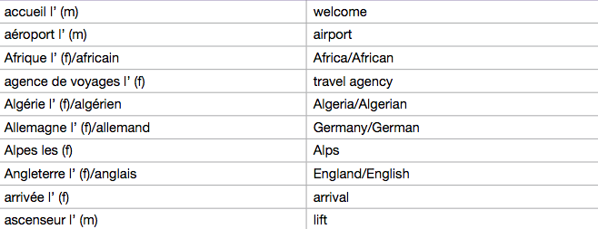

Travel & tourism (2/12)

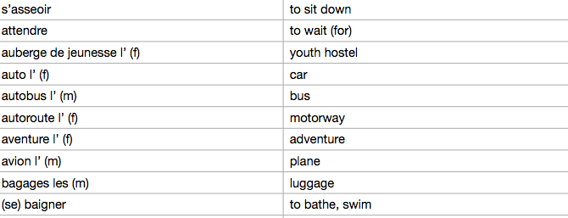

Travel & tourism (3/12)

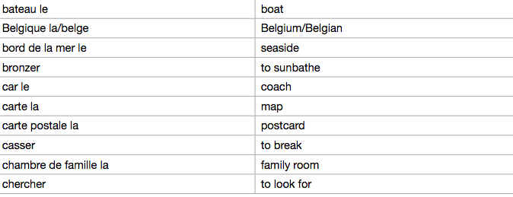

Travel & tourism (4/12)

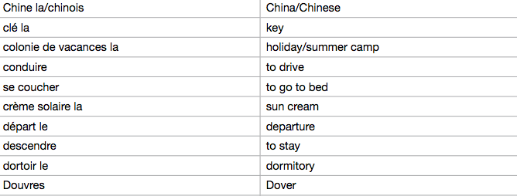

Travel & tourism (5/12)

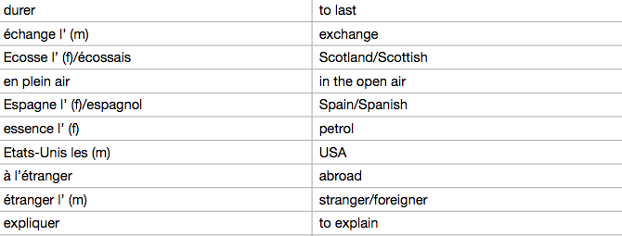

Travel & tourism (6/12)

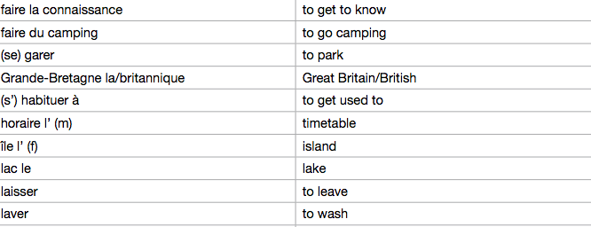

Travel & tourism (7/12)

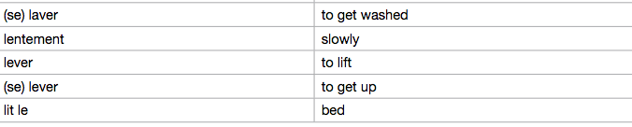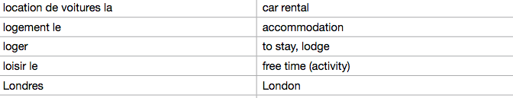

Travel & tourism (8/12)

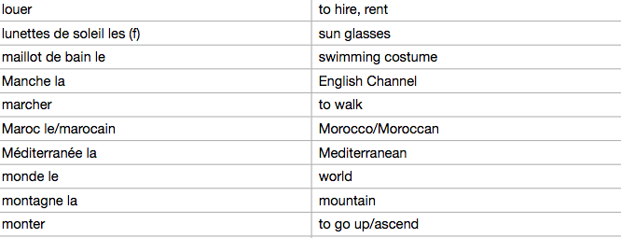

Travel & tourism (9/12)

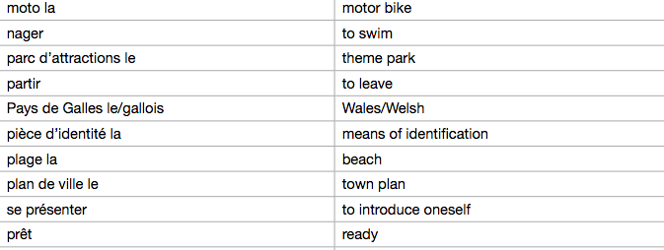
Travel & tourism (10/12)

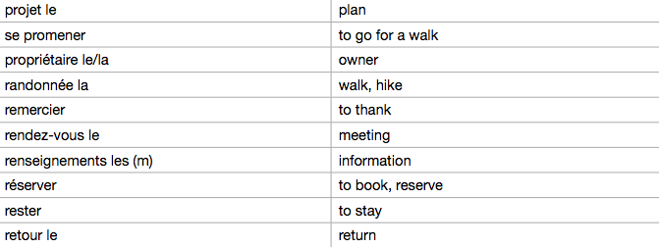

Travel & tourism (11/12)

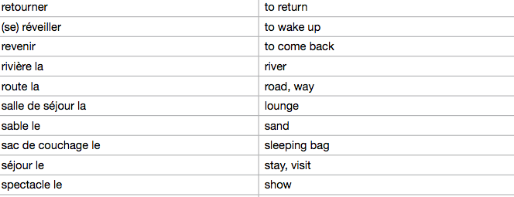

Travel & tourism (12/12)
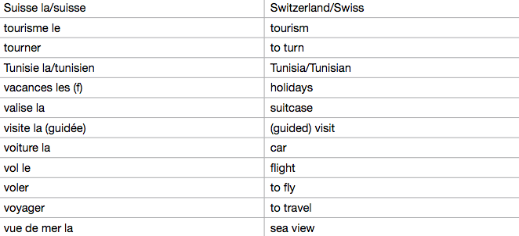
My studies (1/1)

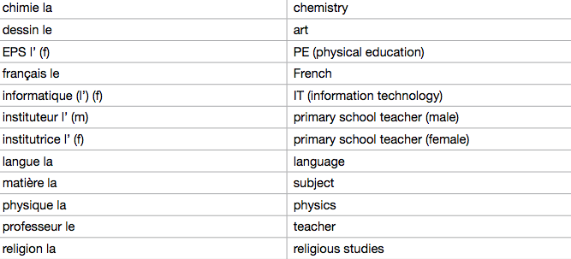

Life at school/college (1/5)

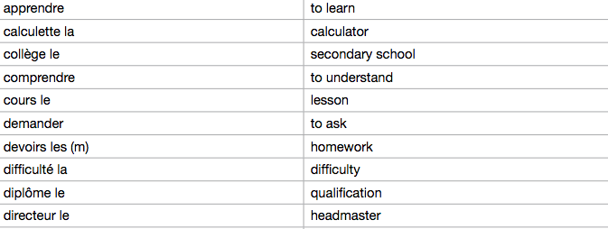

Life at school/college (2/5)

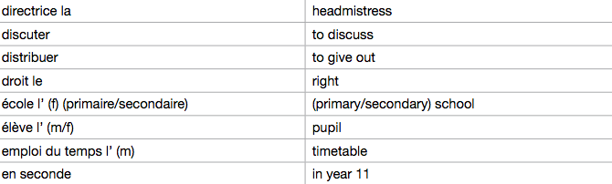
Life at school/college (3/5)

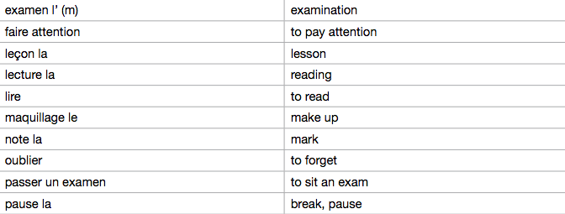

Life at school/college (4/5)

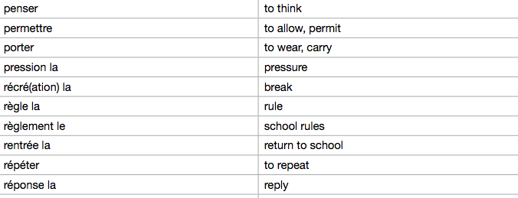

Life at school/college (5/5)

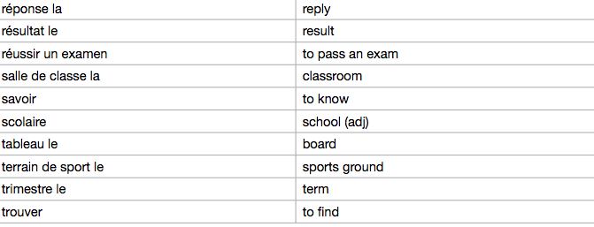

Jobs, career choices and ambitions (1/3)

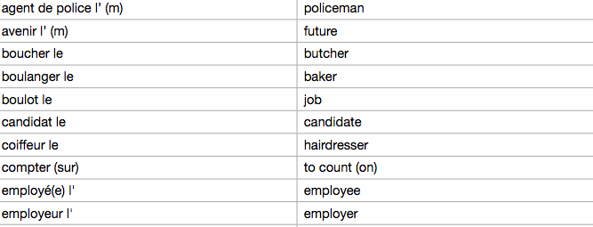

Jobs, career choices and ambitions (2/3)

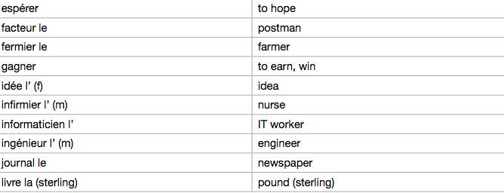

Jobs, career choices and ambitions (3/3)

