THEME 2

Home, town, neighbourhood & region (1/13)

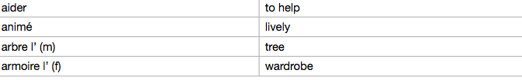
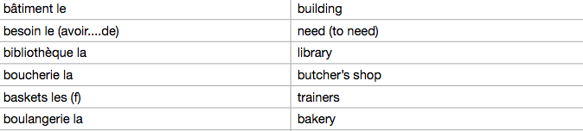

Home, town, neighbourhood & region (2/13)

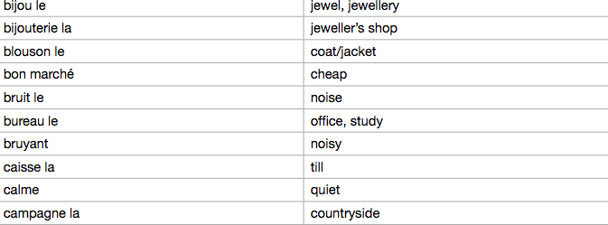

Home, town, neighbourhood & region (4/13)

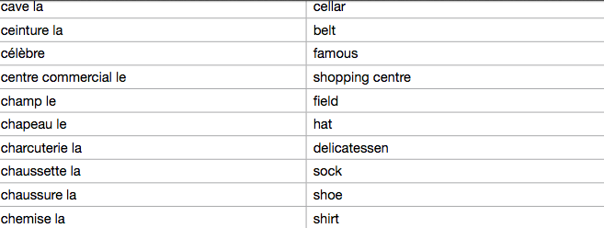

Home, town, nieghbourhood & region (5/13)
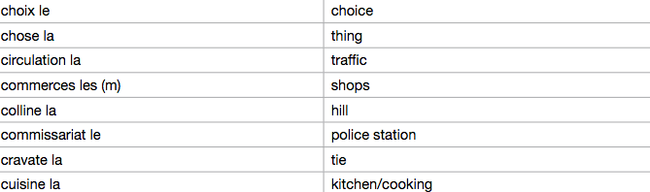

Home, town, nieghbourhood & region (6/13)

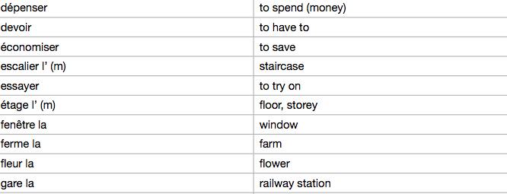

Home, town, neighbourhood & region (7/13)

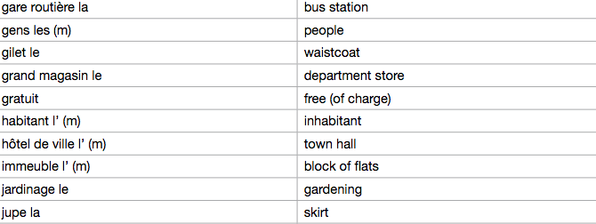

Home, town, neighbourhood & region (8/13)

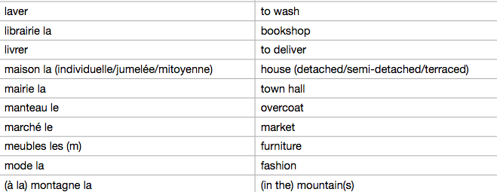

Home, town, neighbourhood & region (9/13)

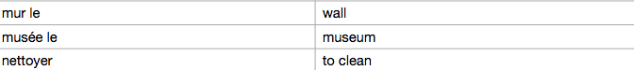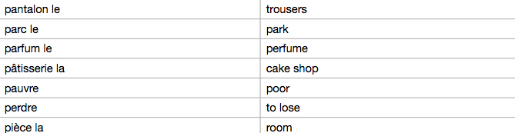
Home, town, neighbourhood & region (10/13)

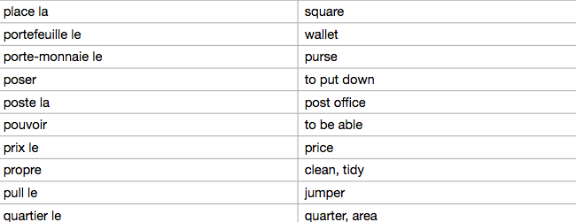

Home, town, neighbourhood & region (11/13)

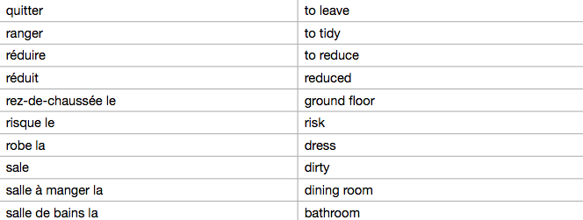

Home, town, neighbourhood & region (12/13)

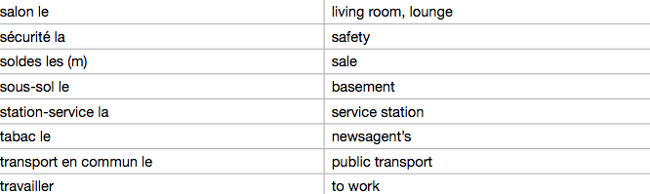

Home, town, neighbourhood & region (13/13)

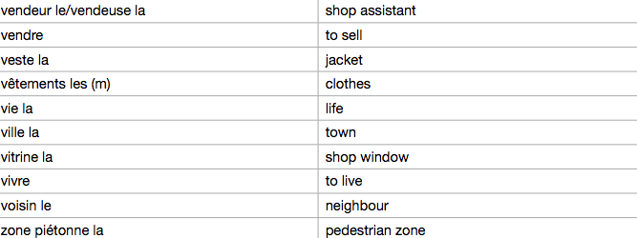

Social issues (1/5)

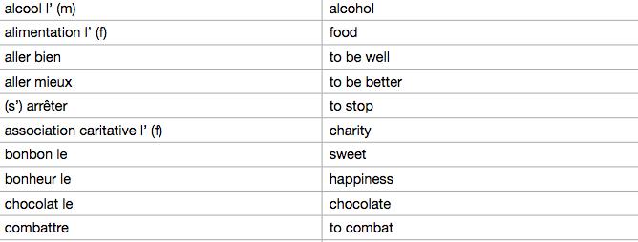

Social issues (2/5)

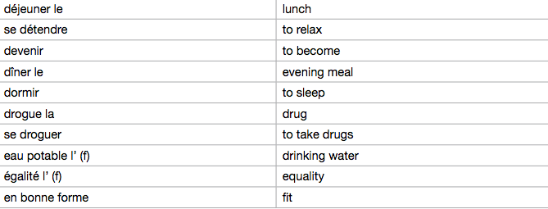

Social issues (3/5)

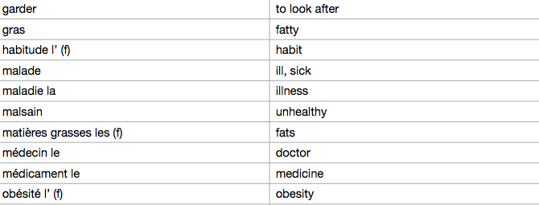

Social issues (4/5)

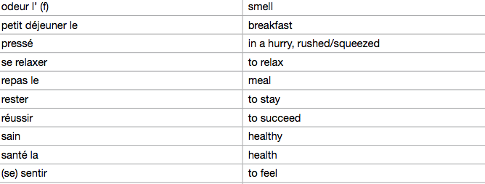

Social issues (5/5)

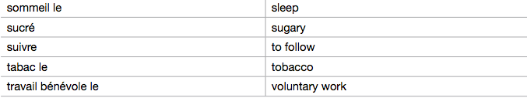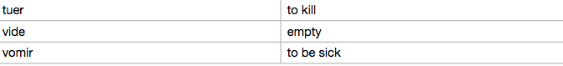

Global issues (1/3)

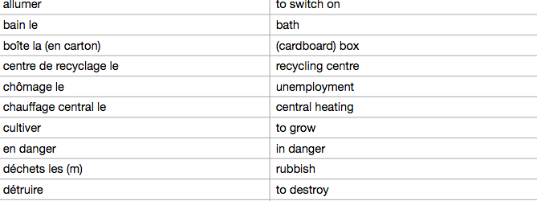

Global issues (2/3)
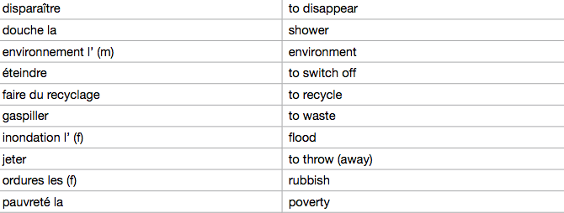

Global issues (3/3)

