THEME 1

Me, my family & friends (1/8)
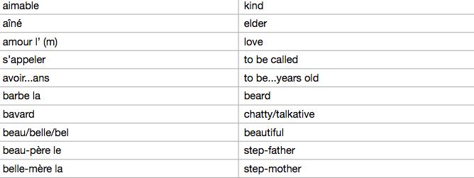
Me, my family & friends (2/8)
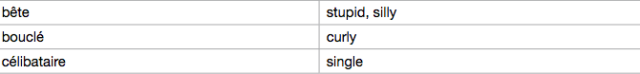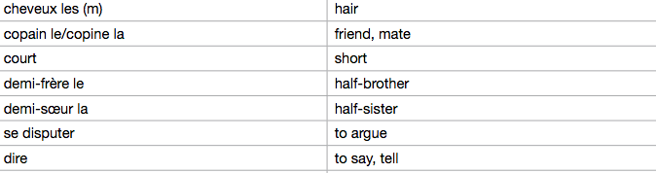

Me, my family & friends (3/8)

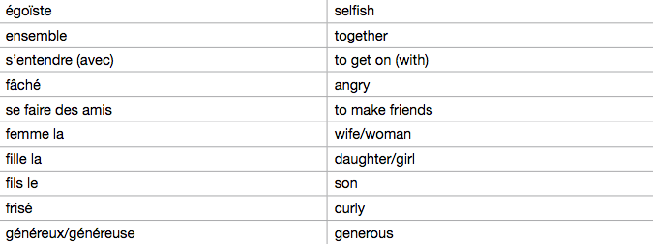

Me, me family & friends (4/8)

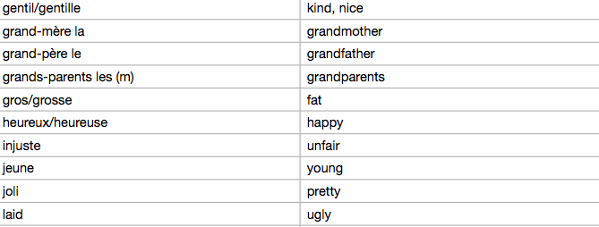

Me, my family & friends (5/8)

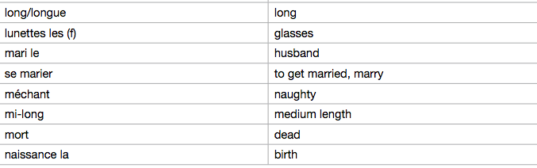

Me, my family & friends (6/8)

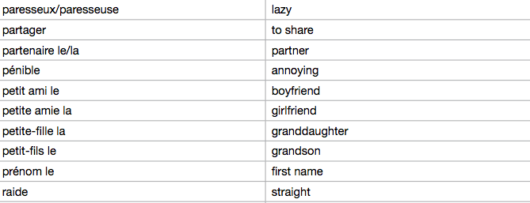

Me, my family & friends (7/8)

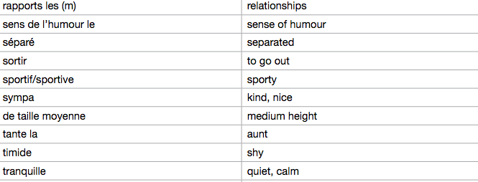

Me, my family & friends (8/8)

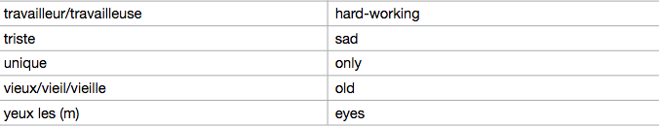

Technology in everyday life (1/4)

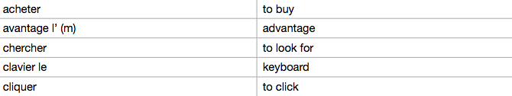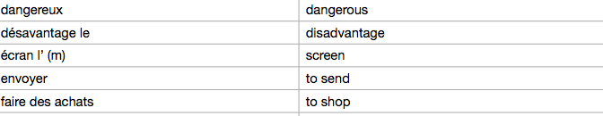

Technology in everyday life (2/4)

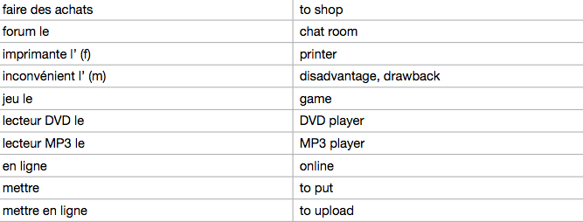

Technology in everyday life (3/4)

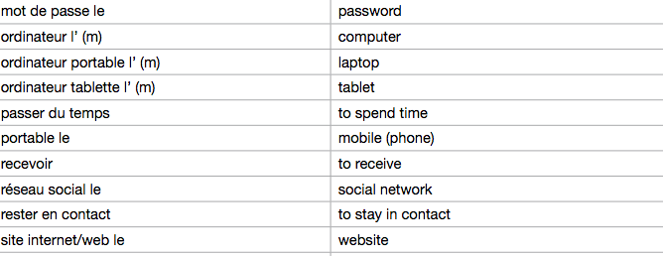

Technology in everyday life (4/4)
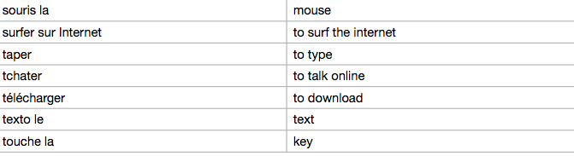

Free-time activities (1/11)

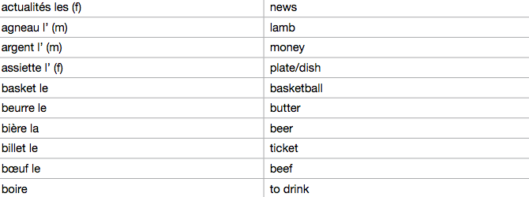

Free-time activities (2/11)

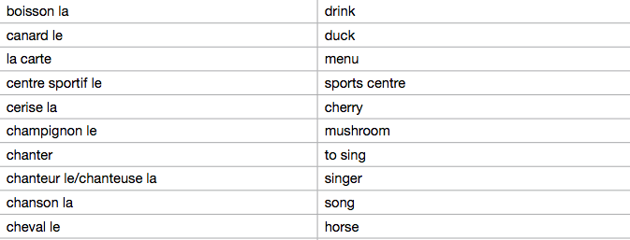

Free-time activities (3/11)

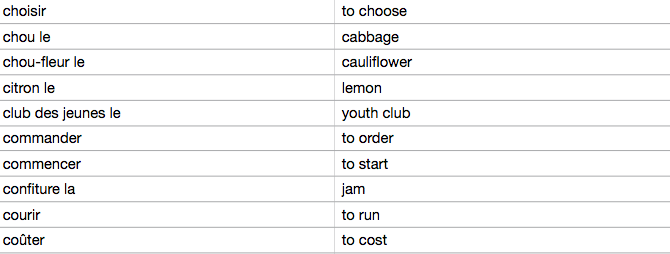
Free-time activities (4/11)
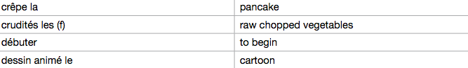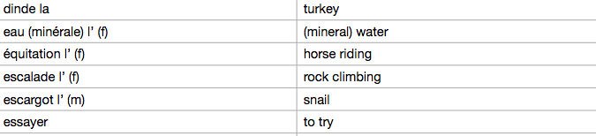

Free-time activities (5/11)

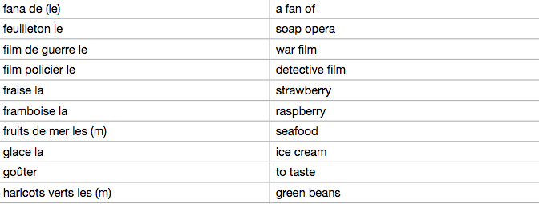

Free-time activities (6/11)

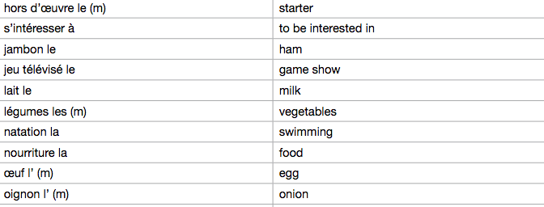

Free-time activities (7/11)

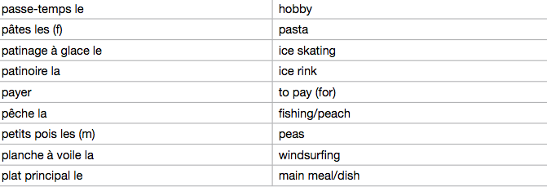

Free-time activities (8/11)

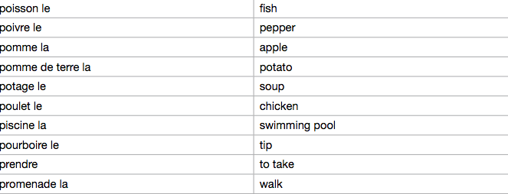

Free-time activities (9/11)

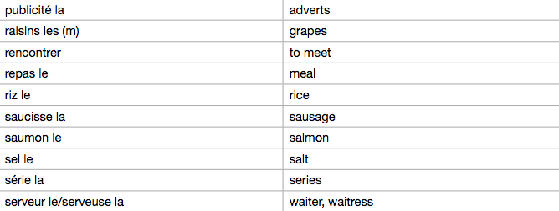

Free-time activities (10/11)
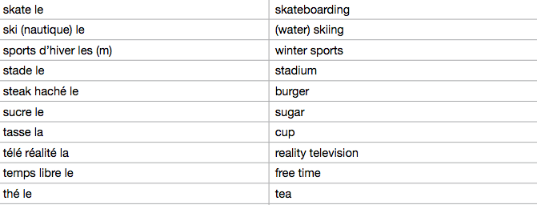

Free-time activities (11/11)

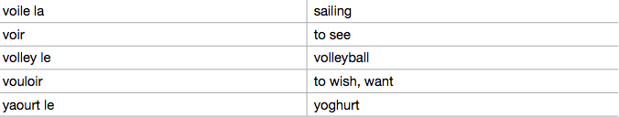

Customs & festivals in French-speaking countries (1/2)
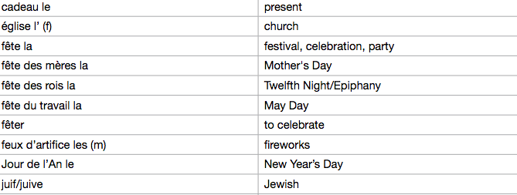

Customs & festivals in French-speaking countries (2/2)
