Assessment 1  Year 7 French assessment overview – 2018-2019 | Completed in class by 7th December 2018
Skill areas | Reading and writing
Topic | Hola + la familia
Items to revise | - Giving basic information about yourself  - Numbers to 31 + dates  - Describing other people  - Opinions  - School equipment
Types of questions | - Inferring meaning from sentences  - Identifying words in Spanish and answering in questions in English  - Translating a passage from English into Spanish  - Writing a paragraph in Spanish. Check spellings, accents and use correct verb forms
Assessment 2  Year 7 Exams | w/c 03/06/2019
Skill areas | Reading and listening
Topic | Self, family and town
Items to revise | - Recognising 3 tenses. Past / present / future  - Where you live and  - Places in town  - Describing where things are  - Chores in the house  - Sports
Type of questions | - Understanding spoken and written Spanish with familiar and unfamiliar words  - Answering questions in both English and Spanish  - Gap fill in Spanish  - Translating a passage from Spanish into English
Revision references | - Your classbook and vocabulary sheets  - The textbook: online digital copy of ¡Claro! 1 - kerboodle  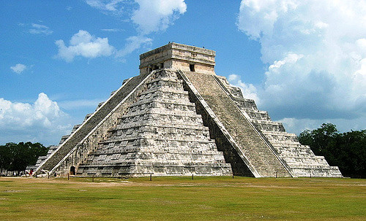  Online learning tools:  - www.linguascope.com  - Username: Cothammfl  - Password: learning  - www.languagesonline.org.uk  - BBC Bitesize KS3 Spanish  - www.Quizlet.com  - www.memrise.com

